High-level questions:
- Is there a correlation between the mother’s health (i.e.prolonged NVP and consequent hospitalisation) and developmental milestones (i.e. weight, height, head circumference, BMI) of children?
- Is there a higher risk of growth and development issues for children of mothers who experienced HG compared to mothers who did not?

—
MoBa questions overview

Mother’s data (condition)

Questionnaire 3

Q27. Hospitalized due to pNVP CC137-145

Q52. Any of the following problems 13-16 17-20 21-24 25-28 29+ week
5. Long-term nausea/vomiting CC388 CC389 CC390 CC391 CC392
11. Unusual fatigue/drowsiness CC460 CC461 CC462 CC463 CC464
29. Depression CC676 CC677 CC678 CC679 CC680

Questionnaire 4: 6 months

Q49. When you think back to the time just after the birth, did you feel depressed during that period?

Q92. Have you experienced any of the following feelings during the last week?
DD827-832
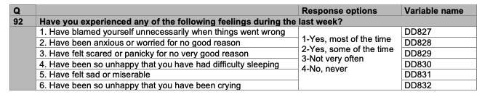
Q27. Have you been admitted to the hospital since you became pregnant? If yes, why and when were you hospitalised?
Prolonged nausea and vomiting CC141 CC142 CC143 CC144 CC145
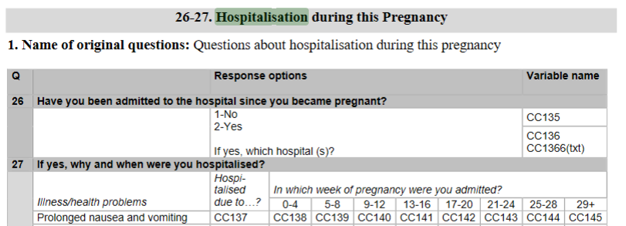

Questionnaire 5: 18 months
Q107. How often do you have negative feelings, such as blue mood, despair, anxiety, depression?
EE696

Should we include this also?
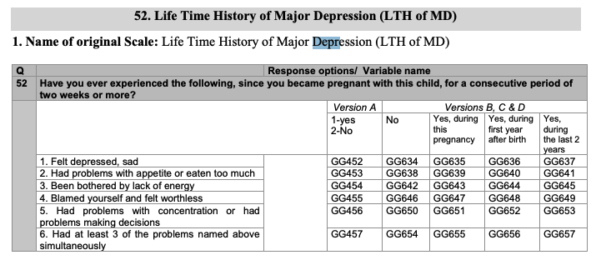

Child’s data (outcomes)
Questionnaire 4: 6 months

Q1. Basic info at birth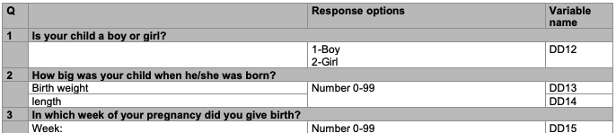

Q26. Child’s length, weight, head circumference between 6wk and 6mo
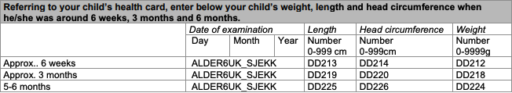

Q27. Does your child have/had any of the following health problems?

Questionnaire 5: 18 months
(v.A) Q18 Does your child have/had any of the following problems?
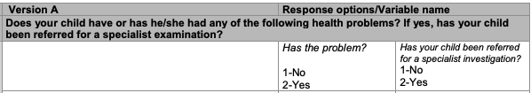

(v.B-D) Q16. Does your child have/had any of the following problems?
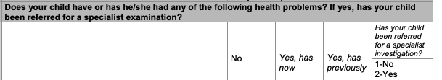

Q30 What were your child’s length, weight, and head circumference?
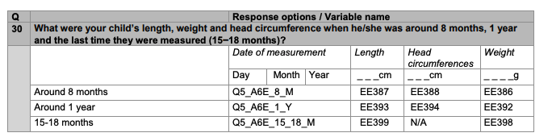

Questionnaire 6: 36 months

Q1. Child’s height and weight between 15-36 months
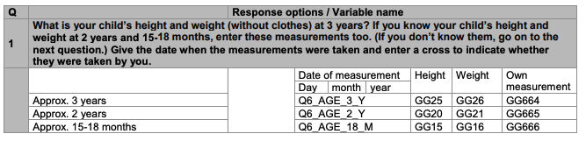

Q3. Has your child suffered any long-term illness or health problems since 18 months?
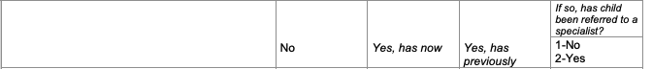

Questionnaire 7: 5 years old

Q1. Child’s height and weight at 5 years old
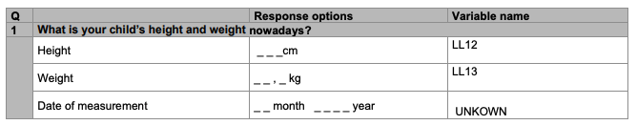

Questionnaire 8: 7 years old

Q1. Child’s height and weight at 7 years old
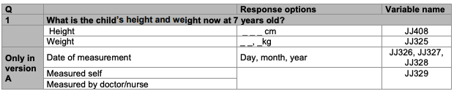

(v.A) Q26. Does the child have/ever had any illnesses or health problems
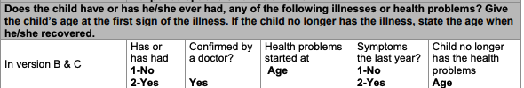

(other versions) Q26. Does the child have/ever had any illnesses or health problems

Questionnaire 9: 8 years old

Q7. Child height and weight at 8 years old
